Central Connecticut State University

**BUILDING A MINI MIPS MACHINE**

**Report 1**

prepared by

Thi Minh Huyen Le

Brendan Manzolli

Erik Marrero

Fall - 2021

1. **Tasks:**

Thi Minh Huyen Le: Regfile module and ALU module, and combining all parts from members.

Brendan Manzolli: Control Unit Truth Table, Diagrams, Description

Erik Marrero: 16-bit CPU, Multiplexors

1. **Description**

This is a simplified single-cycle datapath capable of executing immediate arithmetic and logic instructions(addi, slti, andi, ori) as well as all R-type instructions(add, sub, and, or, slt) Some of the major components include the Instruction Memory, 16-bit ALU and Register File.

The datapath is provided with 16 bits of instruction. The first 4 bits are reserved for a specific operation either R-type or I-type. If the instruction is R-type the next 2 bits are for the source register followed by 2 bits for the transition register and 2 bits for the destination register. The last 8 bits for R-type instruction are unused. If the Instruction is I-type the 2 bits following the operation code are reserved for the source register. The next 2 bits are for the transition register leaving 8 bits for the value or address.

The “and” operation performs a logical conjunction on two expressions returning a value of true, or 1 in this case, if both expressions are true. The “or” operation returns true if either one of the expressions is true. The “add” operator computes the sum of two expressions and returns the result. The “sub” operator computes the difference of two expressions and returns the result. The “slt” operator tests expression 1 is less than expression 2. If expression 1 is less than expression 2 register 1 is set to 1 otherwise register 1 is set to 0. The “andi” operator does a bitwise “and” of two 32 bit patterns. At run time the 16-bit immediate operand is padded on the left with zero bits to make a 32 bit operand. The “ori” operator logically “or”s the lower 16 bits of the contents of a general-purpose register with a 16 bit unsigned integer and stores the result in another general-purpose register. The “addi” operator computes the sum of expression 1 and a constant and returns the result in register 1. The “slti” operator compares expression 1 with immediate value and returns 1 to register 1 if the statement is true. Otherwise, register 1 gets 0.

Instructions:

|  |  |  |  |  |  |
| --- | --- | --- | --- | --- | --- |
| Instruction (I-Type: addi) | Opcode  (4 bits) [15-12] | Rs  (2 bits) [11-10] | Rt (2 bits) [9-8] | Value or Address  (8 bits) [7-0] | Binary Instruction |
| addi $t1, $0, 15 ($t1=15) | 0111 | 00 | 01 | 00001111 | 0111000100001111 |
| addi $t2, $0, 7 ($t2= 7) | 0111 | 00 | 10 | 00000111 | 0111001000000111 |

|  |  |  |  |  |  |  |
| --- | --- | --- | --- | --- | --- | --- |
| Instruction (R-Type) | Opcode  (4 bits) [15-12] | Rs  (2 bits) [11-10] | Rt  (2bit) [9-8] | Rd  (2bits) [7-6] | Unused  (6 bits) [5-0] | Binary Instruction |
| and $t3, $t1, $t2 ($t3= 7) | 0000 | 01 | 10 | 11 | 000000 | 0000011011000000 |
| sub $t2, $t1, $t3 ($t2= 8) | 0001 | 01 | 11 | 10 | 000000 | 0001011110000000 |
| or $t2, $t2, $t3 ($t2=15) | 0011 | 10 | 11 | 10 | 000000 | 0011101110000000 |
| add $t3, $t2, $t3 ($t3=22) | 0010 | 10 | 11 | 11 | 000000 | 0010101111000000 |
| slt $t1, $t3, $t2 ($t1= 0) | 0100 | 11 | 10 | 01 | 000000 | 0100111001000000 |
| slt $t1, $t2, $t3 ($t1= 1) | 0100 | 10 | 11 | 01 | 000000 | 0100101101000000 |

Instruction Set:

|  |  |
| --- | --- |
| **Instruction** | **Opcode** |
| add | 0000 |
| sub | 0001 |
| and | 0010 |
| or | 0011 |
| slt | 0100 |
| addi | 0101 |
| slti | 0110 |
| andi | 0111 |
| ori | 1000 |

1. **Block logic diagrams**

**CPU**

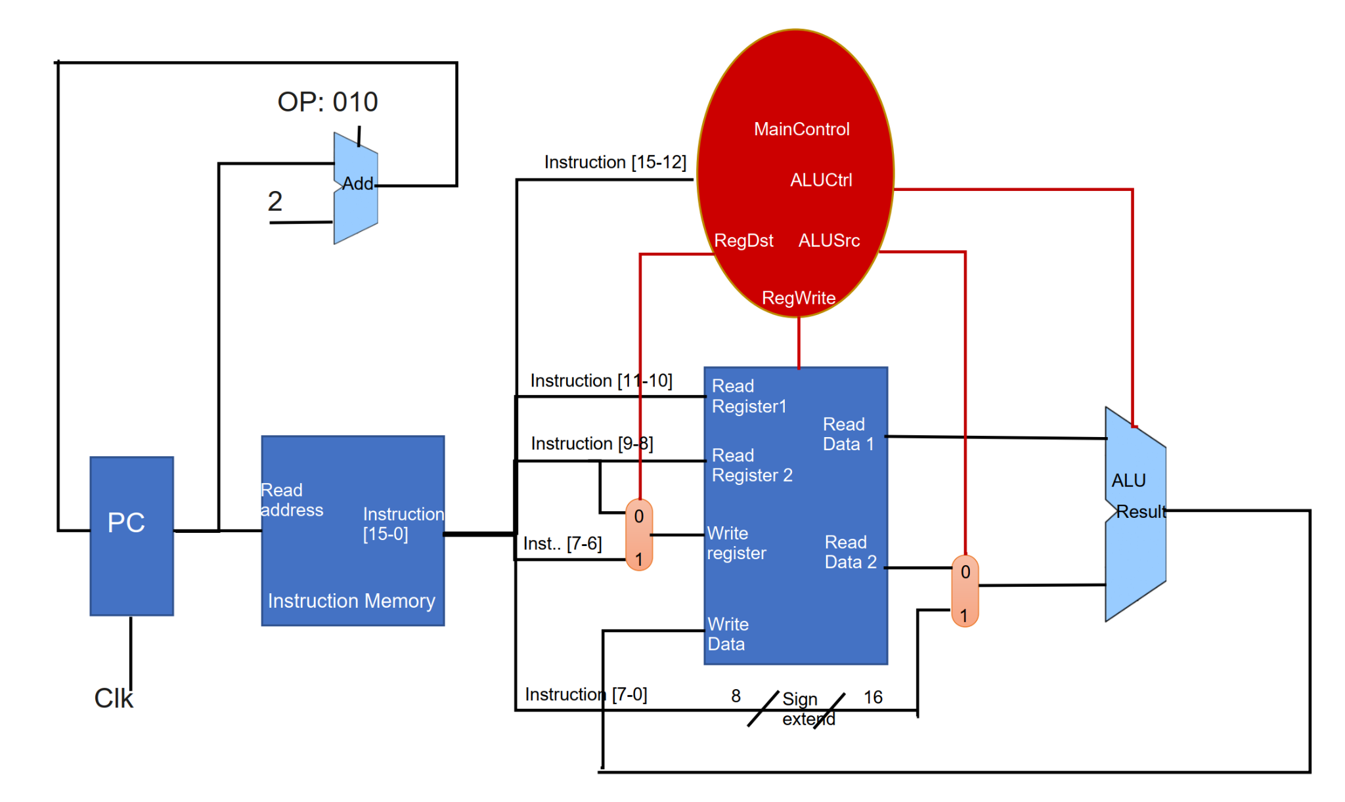

**1-bit ALU for bits 0-14**

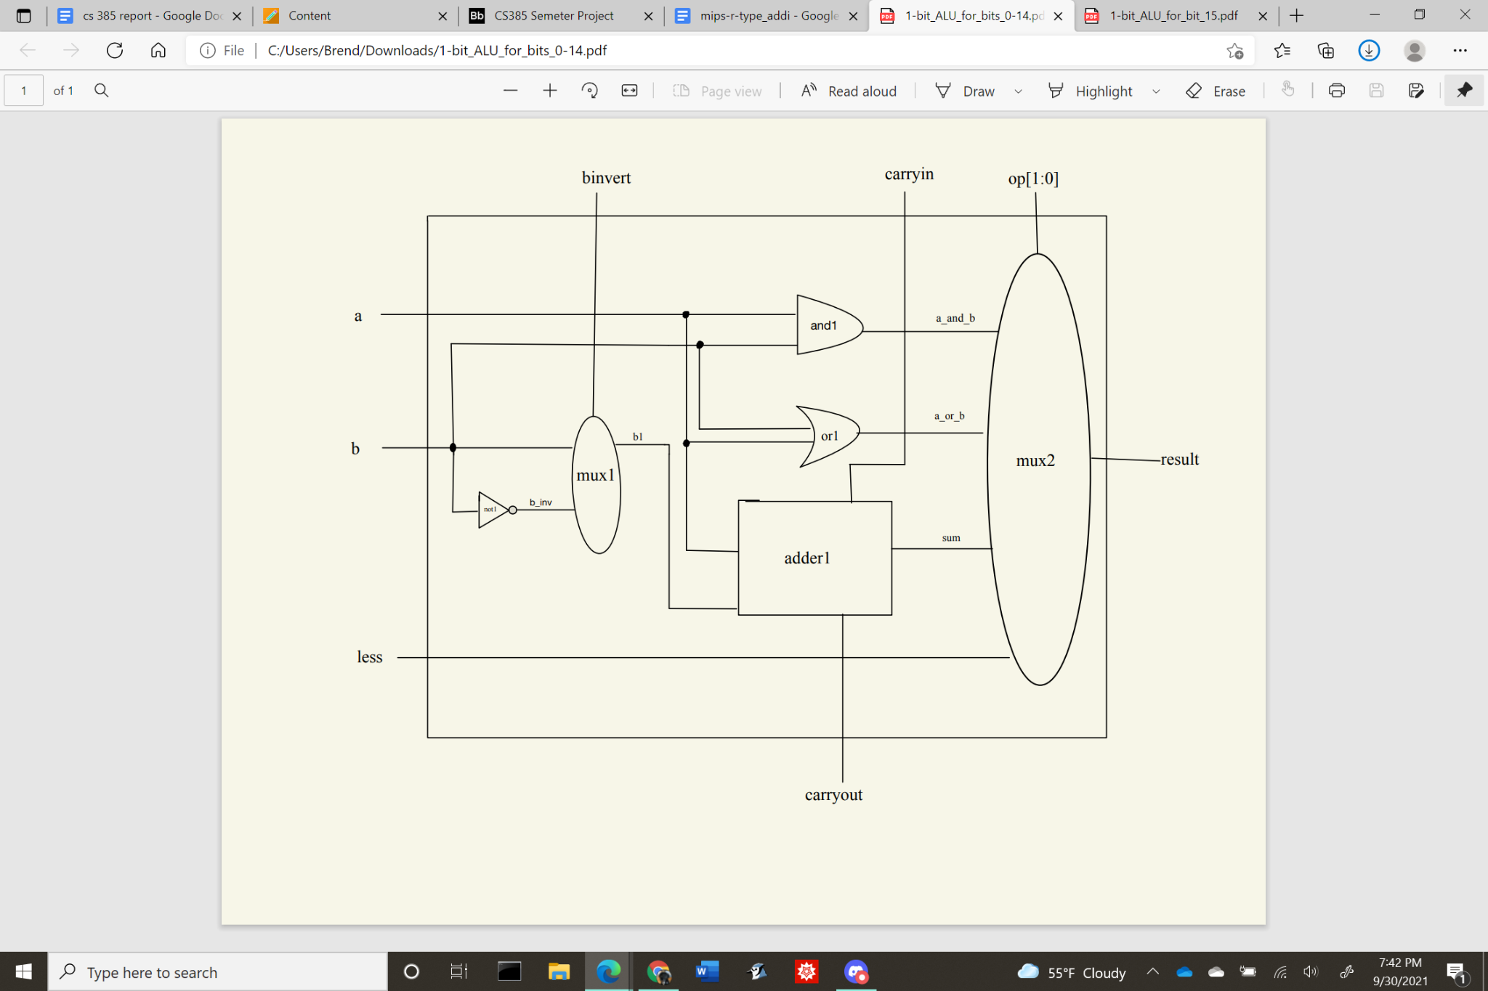

**1-bit ALU for bit 15**

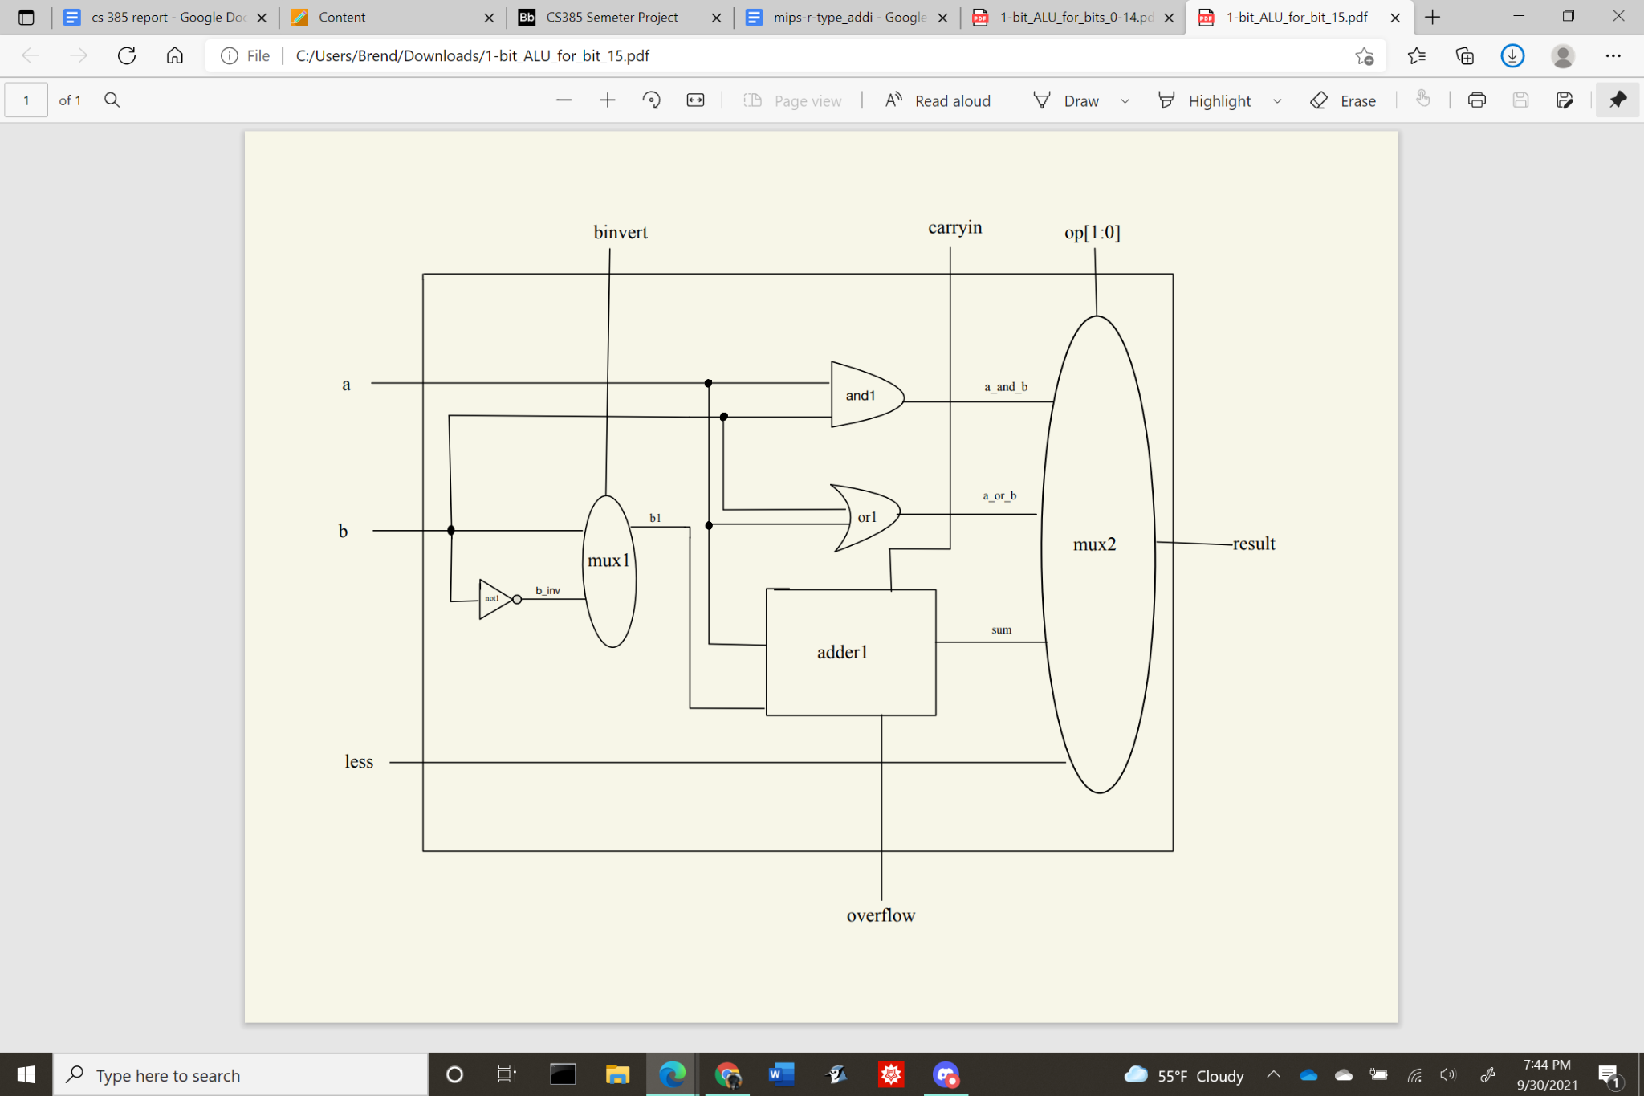

**16bit-ALU**

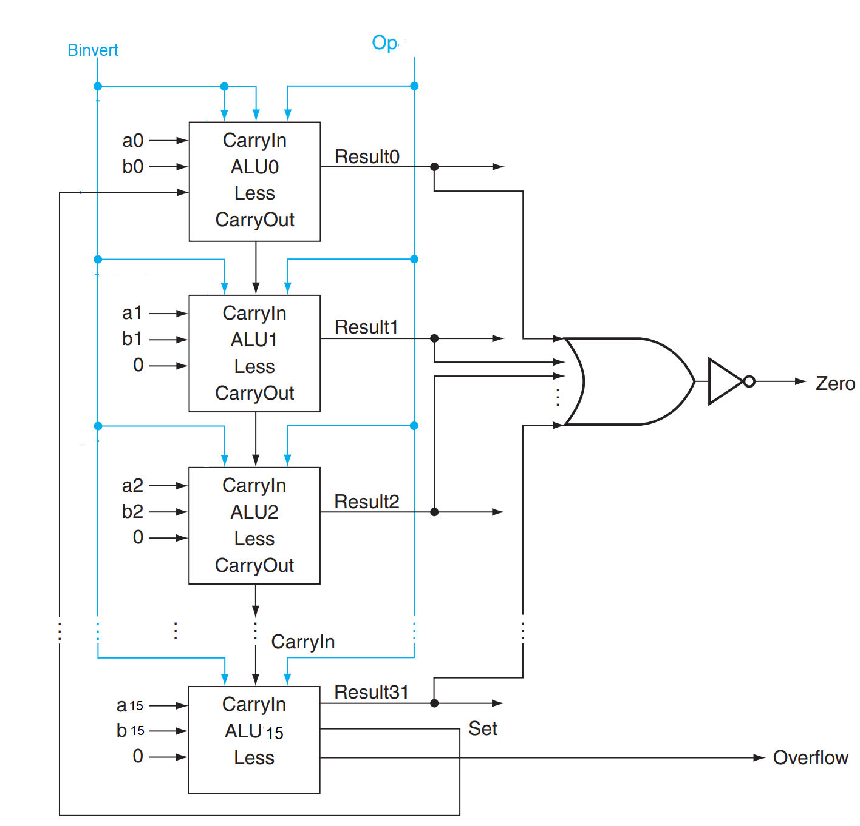

**The truth table for MainControl**

|  |  |  |  |  |  |
| --- | --- | --- | --- | --- | --- |
| **Instruction** | **OpCode** | **RegDst** | **ALUSrc** | **RegWrite** | **ALUCtl** |
| **add** | **0000** | **1** | **0** | **1** | **010** |
| **sub** | **0001** | **1** | **0** | **1** | **110** |
| **and** | **0010** | **1** | **0** | **1** | **000** |
| **or** | **0011** | **1** | **0** | **1** | **001** |
| **slt** | **0100** | **1** | **0** | **1** | **111** |
| **addi** | **0101** | **0** | **1** | **1** | **010** |
| **slti** | **0110** | **0** | **1** | **1** | **111** |
| **andi** | **0111** | **0** | **1** | **1** | **000** |
| **ori** | **1000** | **0** | **1** | **1** | **001** |

1. **Verilog source code**

|  |
| --- |
| // Behavioral model of MIPS - single cycle implementation, R-types and addi,slti,anddi,ori  // --------------REGISTER FILE ---------------  // Assign RR1, RR2 to RD1, RD2  // When RegWrite is on, assign WD to WR  module reg_file (RR1,RR2,WR,WD,RegWrite,RD1,RD2,clock);  input [1:0] RR1,RR2,WR;  input [15:0] WD;  input RegWrite,clock;  output [15:0] RD1,RD2;  reg [15:0] Regs[0:3];  assign RD1 = Regs[RR1];  assign RD2 = Regs[RR2];  initial Regs[0] = 0;  always @(negedge clock)  if (RegWrite==1 & WR!=0)  Regs[WR] <= WD;  endmodule  //-----------END REGISTER FILE-----------  //--------------ALU----------------------  // A 32-bit ALU constructed from the 31 copies of the 1-bit ALU in the top and one 1-bit ALUmsb in the bottom.  module ALU (op,a,b,result,zero);  input [15:0] a;  input [15:0] b;  input [2:0] op;  output [15:0] result;  output zero;  wire c1,c2,c3,c4,c5,c6,c7,c8,c9,c10,c11,c12,c13,c14,c15,c16;    ALU1 alu0 (a[0],b[0],op[2],op[1:0],set, op[2], c1,result[0]);  ALU1 alu1 (a[1],b[1],op[2],op[1:0],1'b0, c1, c2,result[1]);  ALU1 alu2 (a[2],b[2],op[2],op[1:0],1'b0, c2, c3,result[2]);  ALU1 alu3 (a[3],b[3],op[2],op[1:0],1'b0, c3, c4,result[3]);  ALU1 alu4 (a[4],b[4],op[2],op[1:0],1'b0, c4, c5,result[4]);  ALU1 alu5 (a[5],b[5],op[2],op[1:0],1'b0, c5, c6,result[5]);  ALU1 alu6 (a[6],b[6],op[2],op[1:0],1'b0, c6, c7,result[6]);  ALU1 alu7 (a[7],b[7],op[2],op[1:0],1'b0, c7, c8,result[7]);  ALU1 alu8 (a[8],b[8],op[2],op[1:0],1'b0, c8, c9,result[8]);  ALU1 alu9 (a[9],b[9],op[2],op[1:0],1'b0, c9, c10,result[9]);  ALU1 alu10 (a[10],b[10],op[2],op[1:0],1'b0, c10, c11,result[10]);  ALU1 alu11 (a[11],b[11],op[2],op[1:0],1'b0, c11, c12,result[11]);  ALU1 alu12 (a[12],b[12],op[2],op[1:0],1'b0, c12, c13,result[12]);  ALU1 alu13 (a[13],b[13],op[2],op[1:0],1'b0, c13, c14,result[13]);  ALU1 alu14 (a[14],b[14],op[2],op[1:0],1'b0, c14, c15,result[14]);  ALUmsb alu15 (a[15],b[15],op[2],op[1:0],1'b0, c15, c16,result[15],set);    or or1(or01, result[0], result[1], result[2], result[3], result[4], result[5], result[6], result[7], result[8], result[9], result[10], result[11], result[12], result[13], result[14], result[15]);  not not1(zero, or01);  endmodule  // 1-bit ALU for bits 0-2  // A 1-bit ALU that performs AND, OR, addition , subtraction on a and b,  module ALU1 (a,b,binvert,op,less,carryin,carryout,result);  input a,b,less,carryin,binvert;  input [1:0] op;  output carryout,result;  wire sum, a_and_b, a_or_b, b_inv;    not not1(b_inv, b);  mux2x1 mux1(b,b_inv,binvert,b1);  and and1(a_and_b, a, b);  or or1(a_or_b, a, b);  fulladder adder1(sum,carryout,a,b1,carryin);  mux4x1 mux2(a_and_b,a_or_b,sum,less,op[1:0],result);  endmodule  // 1-bit ALU for the most significant bit  // A 1-bit ALU that performs AND, OR, addition , subtraction on a and b, GIVE THE MOST SIGNIFICANT BIT AS AN OUTPUT SUM and overflow  module ALUmsb (a,b,binvert,op,less,carryin,overflow,result,sum);  input a,b,less,carryin,binvert;  input [1:0] op;  output overflow,result,sum;  wire sum, a_and_b, a_or_b, b_inv;    not not1(b_inv, b);  mux2x1 mux1(b,b_inv,binvert,b1);  and and1(a_and_b, a, b);  or or1(a_or_b, a, b);  fulladder adder1(sum,overflow,a,b1,carryin);  mux4x1 mux2(a_and_b,a_or_b,sum,less,op[1:0],result);  endmodule  module halfadder (S,C,x,y);  input x,y;  output S,C;  xor (S,x,y);  and (C,x,y);  endmodule  module fulladder (S,C,x,y,z);  input x,y,z;  output S,C;  wire S1,D1,D2;  halfadder HA1 (S1,D1,x,y),  HA2 (S,D2,S1,z);  or g1(C,D2,D1);  endmodule  // Multiplexor two 1bit-inputs  module mux2x1(A,B,select,OUT);  input A,B,select;  output OUT;  wire wire0, wire1;  not not1 (notS,select);  and and1 (wire0, A,notS),  and2 (wire1, B,select);  or or1 (OUT,wire0,wire1);  endmodule  // Multiplexor four 1bit-inputs  module mux4x1(i0,i1,i2,i3,select,y);  output y; // Output  input i0, i1, i2, i3; // Input ports.  input [1:0] select; // Select lines.    // intermediate wires  wire inv0, inv1; // Inverter outputs.  wire a0, a1, a2, a3; // AND gates outputs.    // Inverters.  not not_1 (inv1, select[1]);  not not_0 (inv0, select[0]);    // 4-input AND gates.  and and_0 (a0, i0, inv1, inv0);  and and_1 (a1, i1, inv1, select[0]);  and and_2 (a2, i2, select[1], inv0);  and and_3 (a3, i3, select[1], select[0]);    // 4-input OR gate.  or or_0 (y, a0, a1, a2, a3);  endmodule  //--------------END ALU-----------------  //--------------MULTIPLEXORS-------------  // Multiplexor two 16-bit inputs.  module mux16bitx2x1 (A,B,Select,Out);  input [15:0] A,B;  input Select;  output [15:0] Out;  mux2x1 m0 (A[0],B[0],Select,Out[0]),  m1 (A[1],B[1],Select,Out[1]),  m2 (A[2],B[2],Select,Out[2]),  m3 (A[3],B[3],Select,Out[3]),  m4 (A[4],B[4],Select,Out[4]),  m5 (A[5],B[5],Select,Out[5]),  m6 (A[6],B[6],Select,Out[6]),  m7 (A[7],B[7],Select,Out[7]),  m8 (A[8],B[8],Select,Out[8]),  m9 (A[9],B[9],Select,Out[9]),  m10 (A[10],B[10],Select,Out[10]),  m11 (A[11],B[11],Select,Out[11]),  m12 (A[12],B[12],Select,Out[12]),  m13 (A[13],B[13],Select,Out[13]),  m14 (A[14],B[14],Select,Out[14]),  m15 (A[15],B[15],Select,Out[15]);  endmodule  // Multiplexor two 2-bit inputs.  module mux2bitx2x1 (A,B,Select,Out);  input [1:0] A,B;  input Select;  output [1:0] Out;  mux2x1 m0 (A[0],B[0],Select,Out[0]),  m1 (A[1],B[1],Select,Out[1]);  endmodule  //--------------END MULTIPLEXORS------------  //--------------MAIN CONTROL---------------  /*** 16-bit CPU control source code ***/  module mainCtrl (op, ctrl);  input [3:0] op;  output reg [5:0] ctrl;  // ctrl bits: RegDst, ALUSrc, RegWrite, ALUCtl  always @(op) case (op)  4'b0000: ctrl <= 6'b101010; // ADD  4'b0001: ctrl <= 6'b101110; // SUB  4'b0010: ctrl <= 6'b101000; // AND  4'b0011: ctrl <= 6'b101001; // OR  4'b0100: ctrl <= 6'b101111; // SLT  4'b0101: ctrl <= 6'b011010; // ADDI  4'b0110: ctrl <= 6'b011111; // SLTI  4'b0111: ctrl <= 6'b011000; // ANDI  4'b1000: ctrl <= 6'b011001; // ORI  endcase  endmodule  //------------END MAIN CONTROL----------------  module CPU (clock,PC,ALUOut, IR);  input clock;  output [15:0] ALUOut, IR, PC;  reg [15:0] PC;  reg [15:0] IMemory[0:511];  wire [15:0] IR, NextPC, A, B, ALUOut, RD2, SignExtend;  wire [2:0] ALUCtrl;  wire [1:0] WR;    /* Test Program */  initial begin  // Assembly | Result | Binary IR  // ------------------------------------------------------  IMemory[0] = 16'b0101_00_01_00001111; // addi $t1, $0, 15 ($t1= 15) 0101 00 01 00001111  IMemory[1] = 16'b0101_00_10_00000111; // addi $t2, $0, 7 ($t2= 7) 0101 00 10 00000111  IMemory[2] = 16'b0010_01_10_11_000000; // and $t3, $t1, $t2 ($t3= 7) 0010 01 10 11 xxxxxx  IMemory[3] = 16'b0001_01_11_10_000000; // sub $t2, $t1, $t3 ($t2= 8) 0001 01 11 10 xxxxxx  IMemory[4] = 16'b0011_10_11_10_000000; // or $t2, $t2, $t3 ($t2= 15) 0011 10 11 10 xxxxxx  IMemory[5] = 16'b0000_10_11_11_000000; // add $t3, $t2, $t3 ($t3= 22) 0000 10 11 11 xxxxxx  IMemory[6] = 16'b0100_11_10_01_000000; // slt $t1, $t3, $t2 ($t1= 0) 0100 11 10 01 xxxxxx  IMemory[7] = 16'b0100_10_11_01_000000; // slt $t1, $t2, $t3 ($t1= 1) 0100 10 11 01 xxxxxx  end  initial PC = 0;  assign IR = IMemory[PC>>1];  // assign WR  mux2bitx2x1 muxWR (IR[9:8], IR[7:6], RegDst, WR);  // assign B  mux16bitx2x1 muxB (RD2, SignExtend, ALUSrc, B);  // Extend 8bit register to 16bit register  assign SignExtend = {{8{IR[7]}},IR[7:0]};    reg_file rf (IR[11:10], IR[9:8], WR, ALUOut, RegWrite, A, RD2, clock);  ALU fetch (3'b010, PC, 16'b10, NextPC, Unused);  ALU exec (ALUCtrl, A, B, ALUOut, Zero);  // MainCtrl convert Input:4-bit OpCode to Output: 6-bit  mainCtrl main (IR[15:12], {RegDst, ALUSrc, RegWrite, ALUCtrl});  always @(negedge clock) begin  PC <= NextPC;  end  endmodule  // Test module  // Turn on and off clock to run instructions  // After 1ns, clock is flipted  module test ();  reg clock;  wire [15:0] WD,IR,PC;  CPU test_cpu(clock,PC,WD,IR);  always #1 clock = ~clock;    initial begin  $display ("clock PC IR WD");  $monitor ("%b %2d %b %2d", clock,PC,IR,WD);  clock = 1;  #14 $finish;  end  endmodule  /* Compiling and simulation  >iverilog mips-r-type+addi.vl  >vvp a.out  clock PC IR WD  1 0 00100000000010010000000000001111 15  0 4 00100000000010100000000000000111 7  1 4 00100000000010100000000000000111 7  0 8 00000001001010100101100000100100 7  1 8 00000001001010100101100000100100 7  0 12 00000001001010110101000000100010 8  1 12 00000001001010110101000000100010 8  0 16 00000001010010110101000000100101 15  1 16 00000001010010110101000000100101 15  0 20 00000001010010110101100000100000 22  1 20 00000001010010110101100000100000 22  0 24 00000001011010100100100000101010 0  1 24 00000001011010100100100000101010 0  0 28 00000001010010110100100000101010 1  1 28 00000001010010110100100000101010 1  */ |

1. **Test result**

